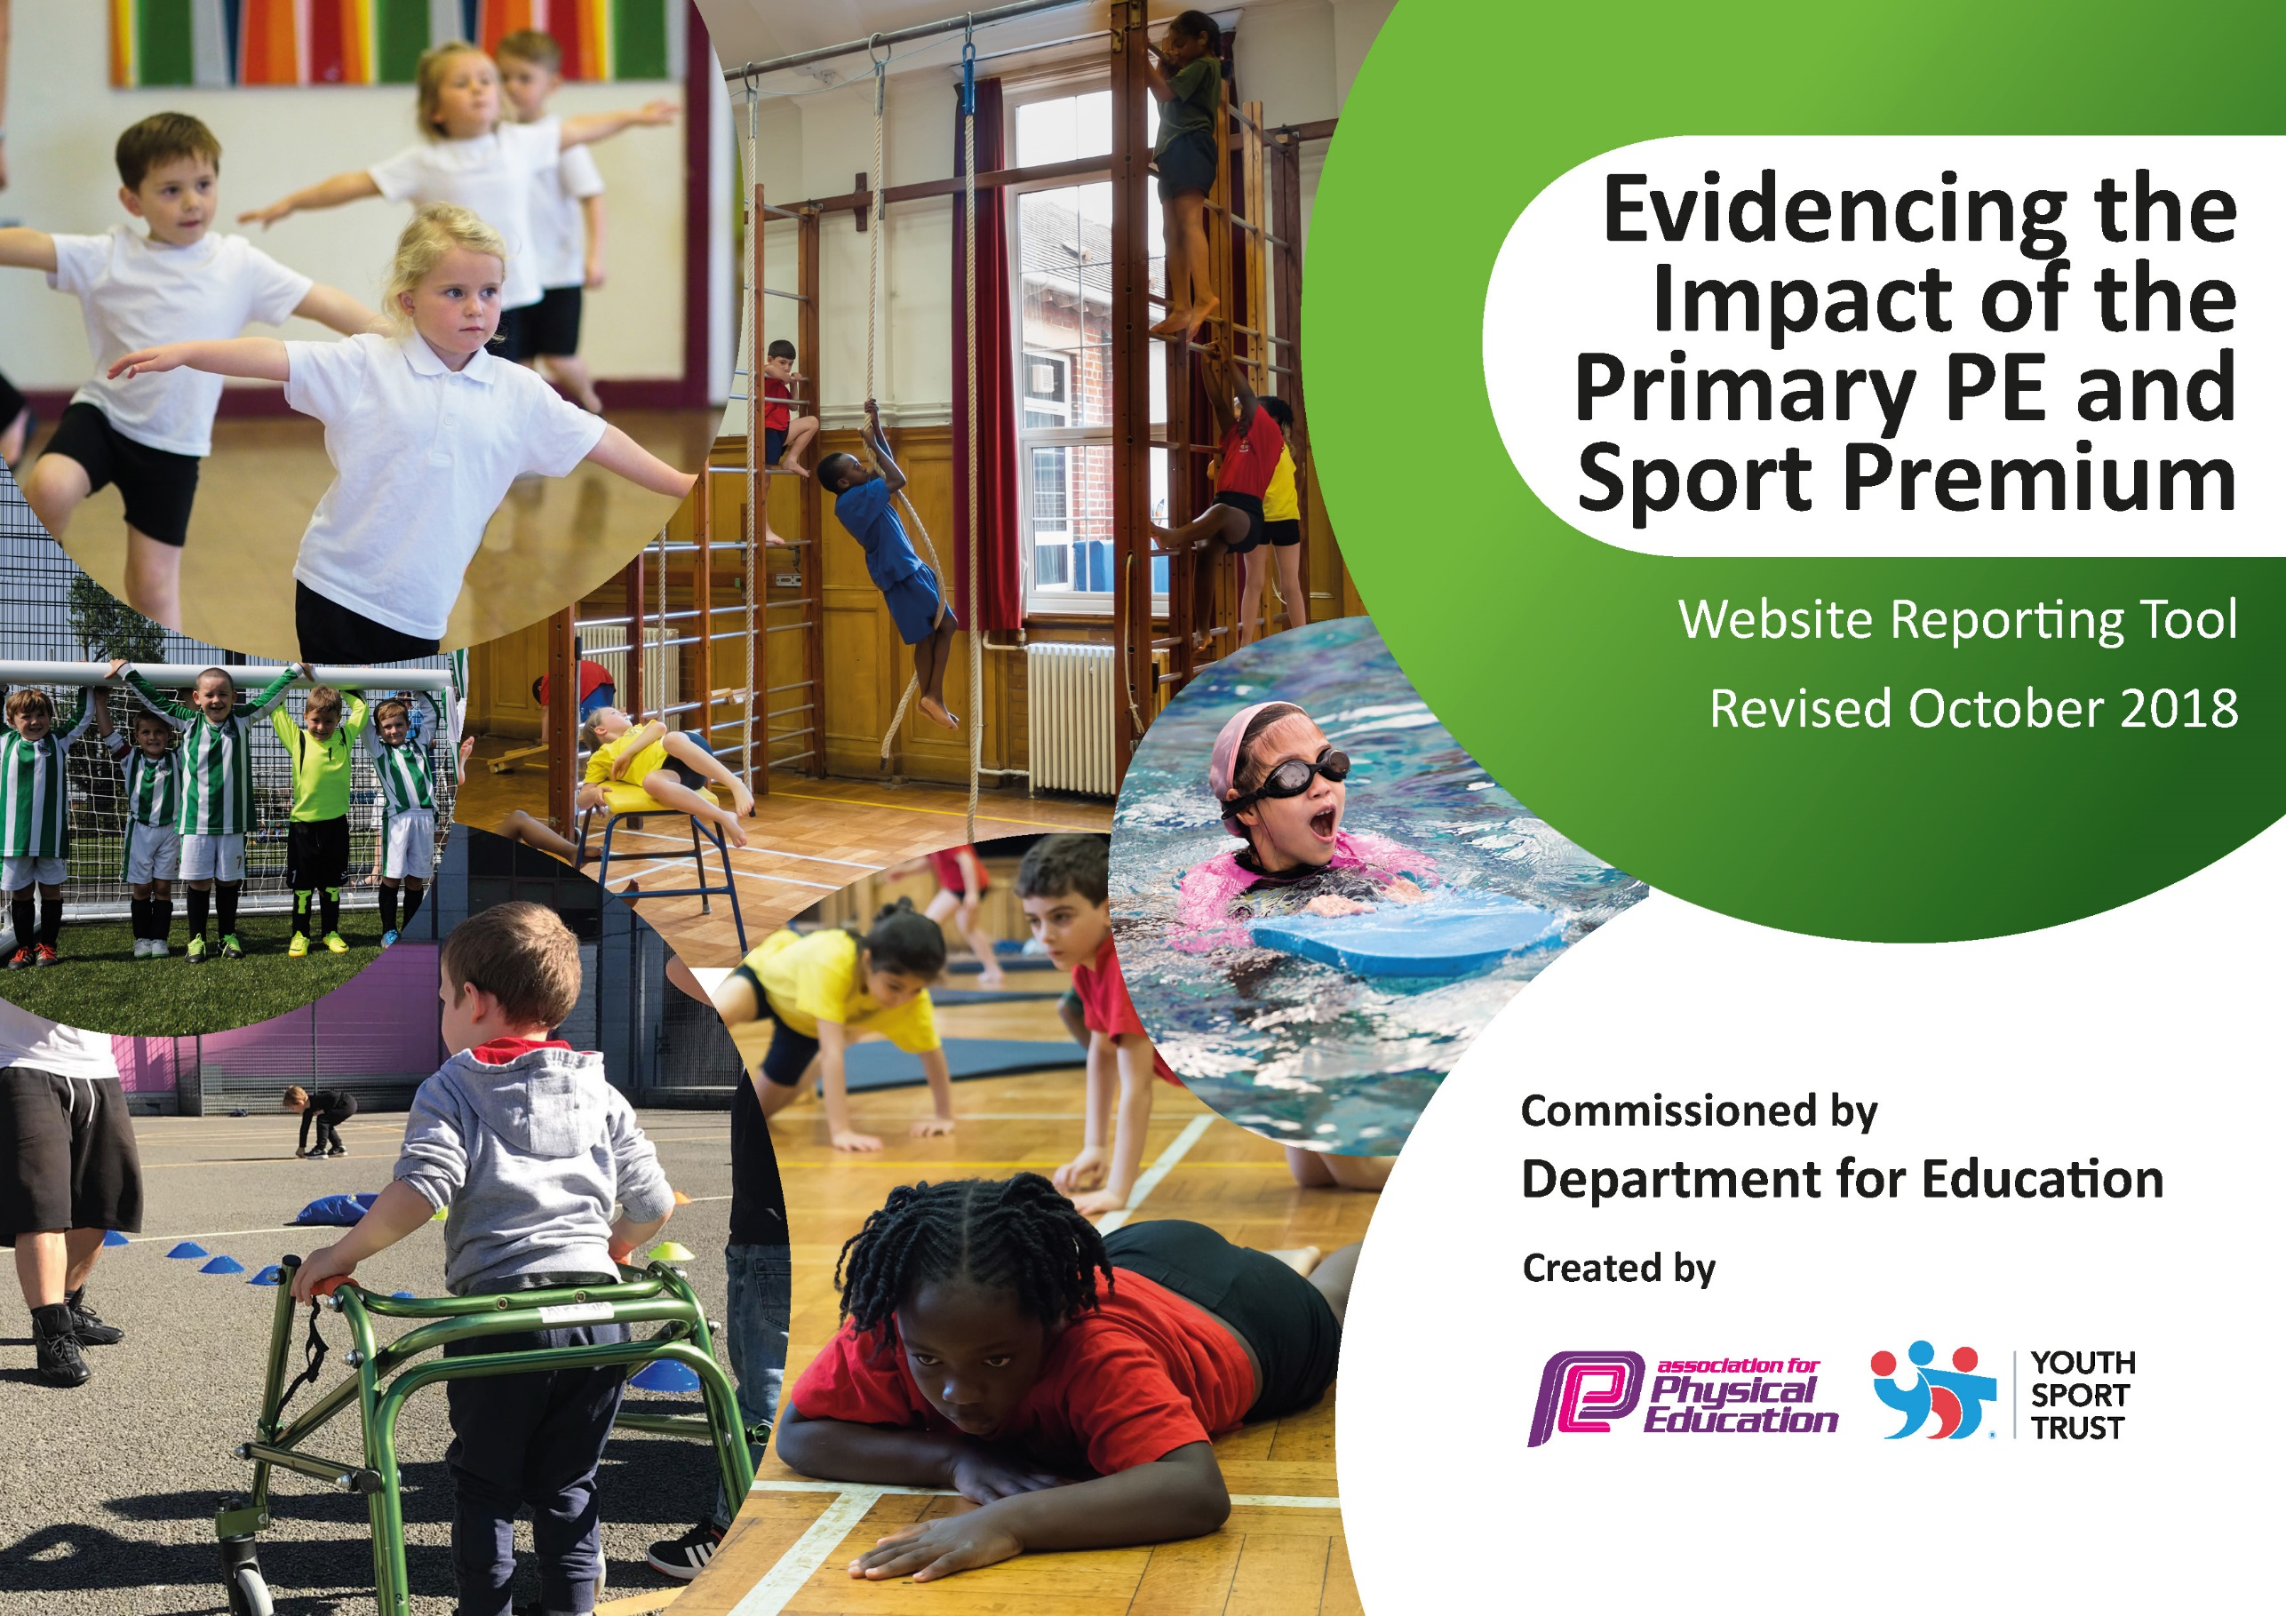

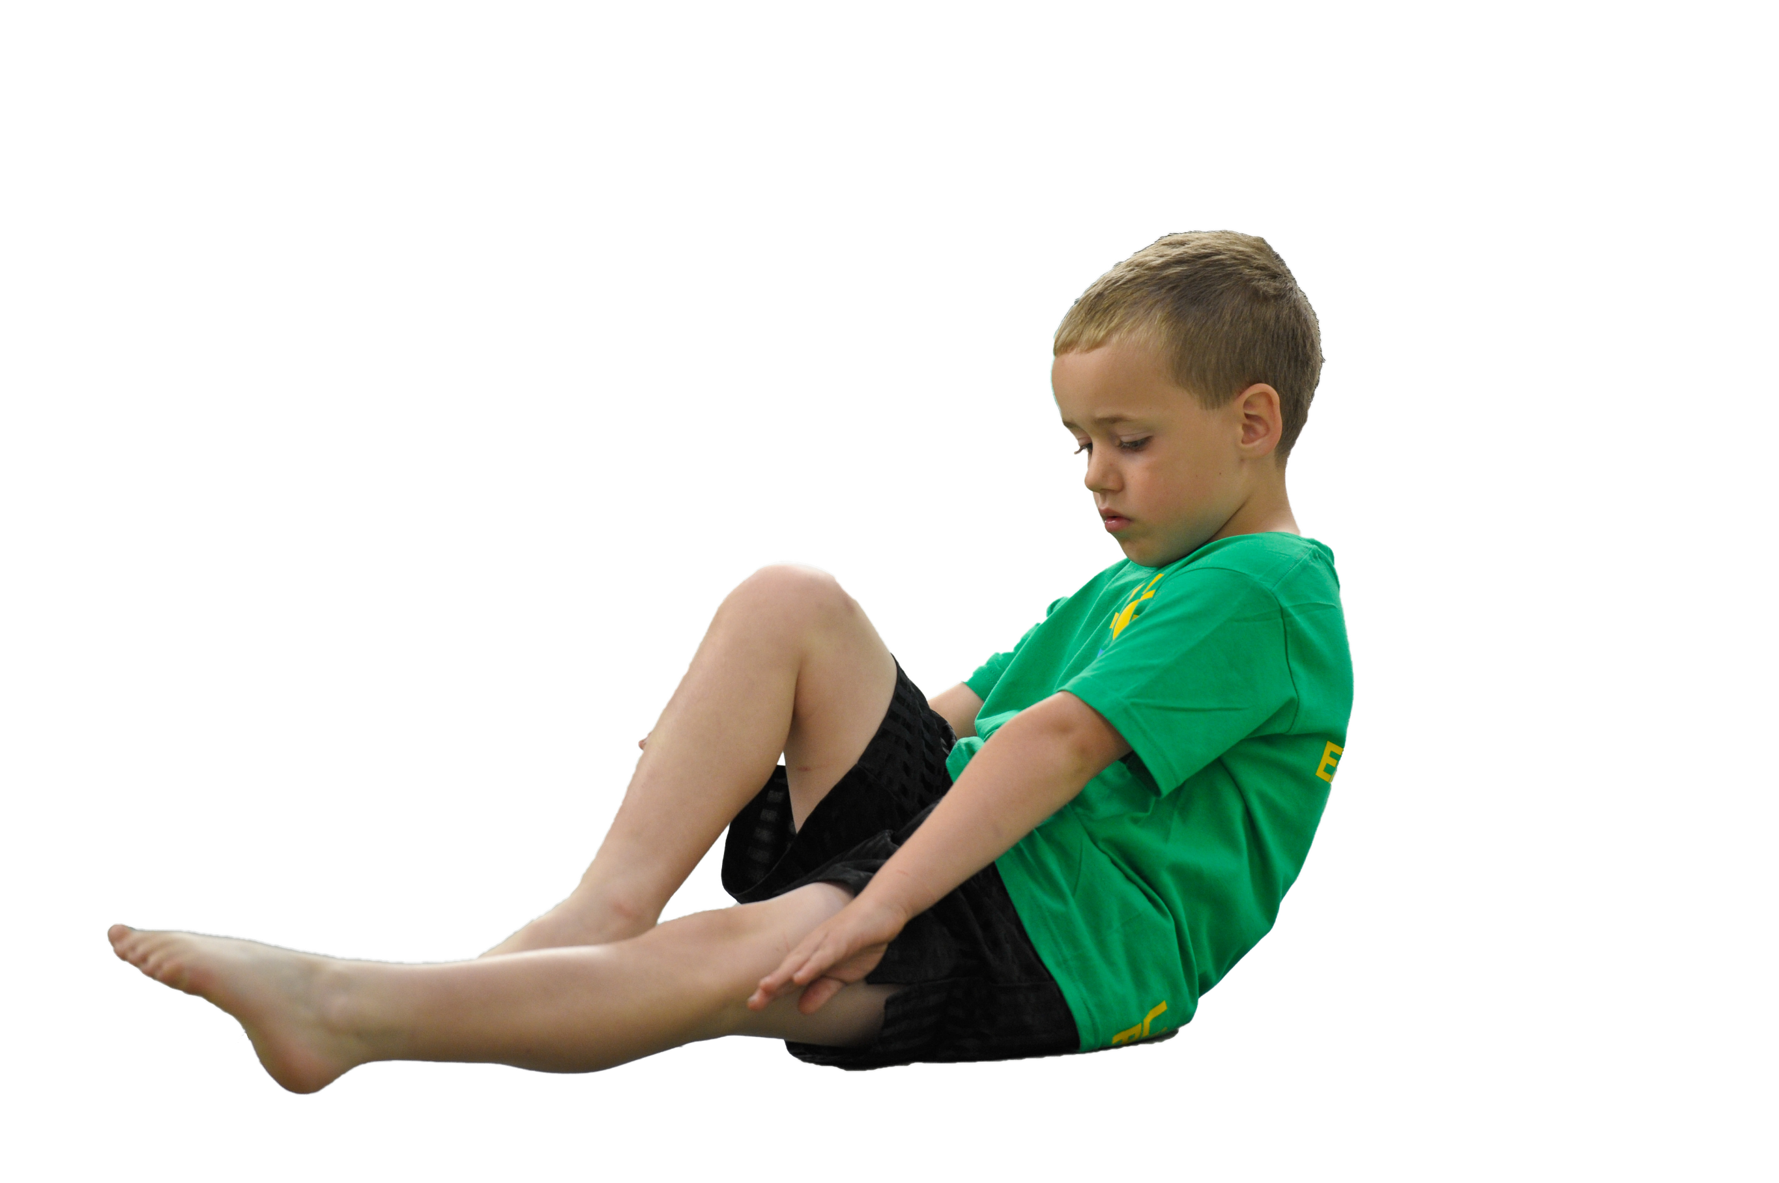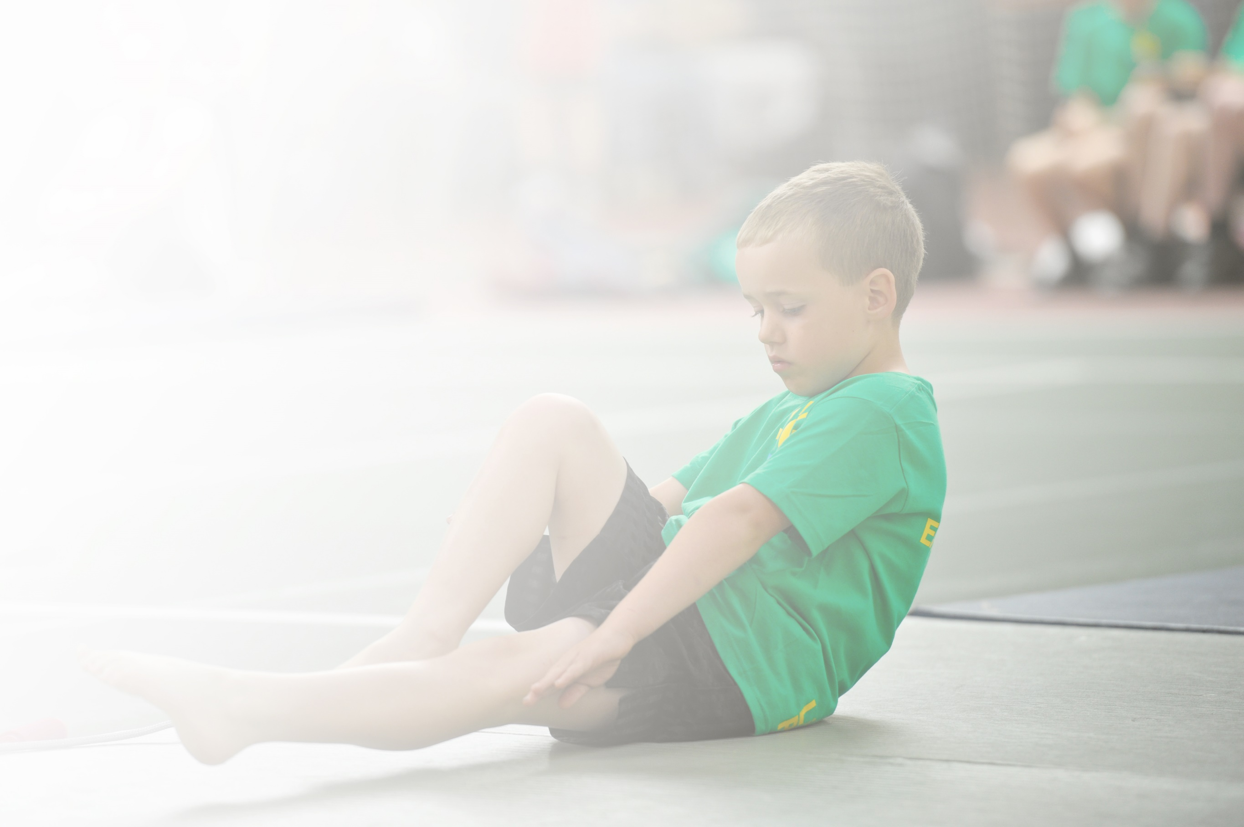Schools must use the funding to make **additional and sustainable** improvements to the quality of Physical Education, Sport and Physical Activity (PESPA) they offer. This means that you should use the Primary PE and Sport Premium to:

* Develop or add to the PESPA activities that your school already offer
* Build capacity and capability within the school to ensure that improvements made now will benefit pupils joining the school in future years

Please visit [gov.uk](https://www.gov.uk/guidance/pe-and-sport-premium-for-primary-schools) for the revised DfE guidance including the 5 key indicators across which schools should demonstrate an improvement. This document will help you to review your provision and to report

your spend. DfE encourages schools to use this template as an effective way of meeting the reporting requirements of the Primary PE and Sport Premium.

We recommend you start by reflecting on the impact of current provision and reviewing the previous

spend. Under the [Ofsted Schools Inspection Framework](https://www.gov.uk/government/publications/school-inspection-handbook-from-september-2015), inspectors will assess how effectively leaders use the Primary PE and Sport Premium and measure its impact on outcomes for pupils, and how effectively [governors](https://www.gov.uk/government/publications/governance-handbook) hold them to account for this.

Schools are required to [publish details](https://www.gov.uk/guidance/what-maintained-schools-must-publish-online#pe-and-sport-premium-for-primary-schools) of how they spend this funding as well as on the impact it has on pupils’ PE and sport participation and attainment by the end of the summer term or by **31 July 2021** at the   
latest.   
  
We recommend regularly updating the table and publishing it  
on your website throughout the year, as evidence of your   
ongoing review into how you are using the money to   
secure maximum, sustainable impact. To see an   
example of how to complete the table please   
click [HERE](http://www.afpe.org.uk/physical-education/wp-content/uploads/afPE-Example-Template-Indicator-2018-Final.pdf).

Support for review and reflection - considering the 5 key indicators from DfE, what development needs are a priority for your setting and your students now and why? Use the space below to reflect on previous spend, identify current need and priorities for the future.

|  |  |
| --- | --- |
| Key achievements to date: | Areas for further improvement and baseline evidence of need: |
| Increased competitive sports working with the Suffolk Sports Partnership  Moving from Bronze Sports mark in 2015, silver in 2016 and Gold Sports mark in 2018, 2019 and 2020  Upgrading sports equipment  Up- skilling staff  Introduction of new sports – for example table tennis and dance  Increased profile of Sport within the school  Enabling all children to take part in sports including SEND and PP children  Encouraging all children to be active in school  Reached the county finals for tennis, table tennis, gymnastics and girls football | Continue to compete in sports events preparing pupils allowing chances to compete at county level.  Maintain Gold Sports mark  Continue to upgrade sports equipment  Provide further Intra school competitions  Support children in sport outside of school  Give children opportunities in a diverse range of sports  Provide additional swimming for those who don’t pass curriculum requirements in year 4+, pupil premium children or those identified with a particular need. |

|  |  |
| --- | --- |
| Meeting national curriculum requirements for swimming and water safety | Please complete all of the below: |
| What percentage of your current Year 6 cohort swim competently, confidently and proficiently over a distance of at least 25 metres?  **N.B.** Even though your children may swim in another year please report on their attainment on leaving  primary school. | Year 6 2019/20 71%  Year 6 2020/21 83%  Year 6 2021/22 88% |
| What percentage of your current Year 6 cohort use a range of strokes effectively [for example, front crawl, backstroke and breaststroke]? | Year 6 2019/20 71%  Year 6 2020/21 83%  Year 6 2021/22 88% |
| What percentage of your current Year 6 cohort perform safe self-rescue in different water-based situations? | Year 6 2019/20 71%  Year 6 2020/21 83%  Year 6 2021/22 88% |
| Schools can choose to use the Primary PE and Sport Premium to provide additional provision for swimming but this must be for activity **over and above** the national curriculum requirements. Have you used it in this way? | We usually do but didn’t 2020/21 due to keeping bubbles intact because of Covid 19. |

**Action Plan and Budget Tracking**

Capture your intended annual spend against the 5 key indicators. Clarify the success criteria and evidence of impact that you intend to measure to evaluate for students today and for the future.

|  |  |  |  |  |  |  |  |  |
| --- | --- | --- | --- | --- | --- | --- | --- | --- |
| **Academic Year:** 2020/21 | **Total fund allocated:** £17,240 | | | **Date Updated: 17/6/21** | | |  | |
| **Key indicator 1:** The engagement of all pupils in regular physical activity – Chief Medical Officer guidelines recommend that primary school children undertake at least 30 minutes of physical activity a day in school | | | | | | | Percentage of total allocation: | |
| % | |
| School focus with clarity on intended **impact on pupils**: | Actions to achieve: | | | Funding allocated: | | Evidence and impact: | Sustainability and suggested next steps: | |
| For all children to be fit and active.  For all children to take part in 2 hours of PE a week.  For all children to take part in competitive sports while they are at Kettlefields Primary School.  To ensure EYFS children are active for at least an hour a day.  To encourage less active children to be active.  Ensure adequate equipment available for PE lessons and clubs.  Increase intra school competitions | Provide swimming lessons for all year 3 and 4 children in the Summer term. (curriculum budget)  Subsidise cost of travel to swimming (£1000)  Regular running  Two hours of PE lessons a week  Sports leaders workshop for 8x year 5 pupils summer 2022 £205  Sports leader’s playmakers award 1hour a week Autumn 1 to encourage year 5 and 6 to lead sports events and play. £350  Mini medics course for all children to learn First aid £160  Equipment for ‘Wonderland’ to keep EYFS active  Playtime equipment to keep all children active | | | £4310 | | All Children have 2 hours PE a week- Observations, PE timetable.  All children at Kettlefields take part in competitive sports with other schools including SEND, PP and less active children- register of attendance at events.  Children are active during all lessons.  Children are active at home doing home learning activities.  Build resilience in children and encourage them to challenge themselves.  Teachers and coaches have sufficient, good equipment to teach a range of sports in PE.  Children can take responsibility to lead PE and sports events.  Children are aware of basic first aid. | 25% | |
| **Key indicator 2:** The profile of PESSPA being raised across the school as a tool for whole school improvement | | | | | | | Percentage of total allocation: | |
| % | |
| School focus with clarity on intended **impact on pupils**: | Actions to achieve: | | | Funding allocated: | | Evidence and impact: | Sustainability and suggested next steps: | |
| To maintain the Gold Sports Mark to inspire pupils  To reward and celebrate achievements to raise the profile of sport.  To report and publicise children’s involvement in sporting activities so our success in sport is recognised by the wider community. | Purchase and provide stickers and Medals for sports day.  Engrave trophies  Children write reports of each event attended.  Certificates presented in assembly.  Write ups to go in the newsletter and on the sports notice board.  Ensure reports are published in the newsletter.  Inform media of achievements (local paper etc)  . | | | £200 | | Children feel their efforts are rewarded and feel motivated.  All parents and children are aware of what sports competitions we have taken part in or know where to find this information.  Younger children are enthused and inspired to follow in older children’s footsteps. | 1% | |
| **Key indicator 3:** Increased confidence, knowledge and skills of all staff in teaching PE and sport | | | | | | | | Percentage of total allocation: |
| % |
| School focus with clarity on intended  **impact on pupils**: | | Actions to achieve: | Funding  allocated: | | Evidence and impact: | | | Sustainability and suggested  next steps: |
| To provide quality first teaching in all PE lessons.  To provide quality first teaching in extra-curricular clubs. | | Dellar sport to provide 1 coaches on Wednesday to deliver a lunchtime club and an afterschool club as well as PE provision in the all day to work alongside teachers.  Coaches from Dellar sport will run a lunch time sports club for up to 30 pupils. PP children will be invited to join FOC.  Dellar Sport will also run an after school multi-sports club for up to 30 pupils with PP children being invited to attend.  These clubs are aimed at maximising participation in sport at Kettlefields and ensuring our most vulnerable pupils get the best possible chances.  All classes will benefit from a high quality PE lesson on a Wednesday. TA’s and teachers will be up skilled.  PE lead will have time to plan and organise events.  Attend INSET for PE Co-ordinator – Primary Network sessions.  Staff to take advantage of training opportunities through School Sports Partnership.  NQT PE training (for RQT- not available last year) £145 through SSP  Staff training for use of orienteering course and Archery equipment | £8620 | | Teaching is deemed to be at least good in all PE lessons.  Extra-curricular clubs are well attended | | | 50% |
| **Key indicator 4:** Broader experience of a range of sports and activities offered to all pupils | | | | | | | | Percentage of total allocation: |
| % |
| School focus with clarity on intended  **impact on pupils:** | | Actions to achieve: | Funding  allocated: | | Evidence and impact: | | | Sustainability and suggested  next steps: |
| Additional achievements:  Extend the variety of sports on offer to children so there is something that appeals to everyone. | | Purchase of Arrows archery equipment and training package through the SSP. £275  Subsidised adventurous activities to offer the children the opportunity to try other physical activity such as water sports, climbing etc | £2000 | | Children have the opportunity to try different sports.  All children can be actively involved in a sport that they enjoy. | | | 12%  . |
| **Key indicator 5:** Increased participation in competitive sport | | | | | | | | Percentage of total allocation: |
| % |
| School focus with clarity on intended  **impact on pupils**: | | Actions to achieve: | Funding  allocated: | | Evidence and impact: | | | Sustainability and suggested  next steps: |
| Enable all children to take part in competitive sport while at Kettlefields.  To increase children’s access to competitive sport.  Enable children to be fit and active for at least an hour a day. | | To maintain membership of the Suffolk Sports Partnership (£745) in order for:  Children to benefit from taking part in competitive sporting events with other schools.  Attend competitions and festivals leading to county finals and community links  Self-Assess using School Sports Games Mark  Provide transport to attend year 3 and 4 youth games, year 5/6 sports hall competition and other sporting fixtures where 10 or more children take part during school hours.  Organise Intra school sports competitions  (One per half term for whole school involvement)  Organise Sports day  Organise Golden Mile  Organise and train Sports leaders  Organise Intra class competition at the end of each unit of PE.  Arrange for sports coaches or volunteer parents to prepare pupils for competitions. | £2000 | | All children take part in competitive sports at least twice while at Kettlefields including SEND, PP and less active children- register of competition attendance  All children regularly take part in competitive sport in school- register of attendance.  All children are active for at least an hour each day- observation, learning walks. | | | 12% |