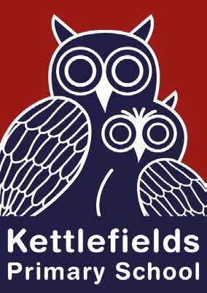
Kettlefields Primary School

A Parents’ Guide to Oracy

What is oracy?
Oracy is the ability to express your thoughts clearly, fluently and effectively through spoken language, whilst also actively listening to and understanding others. Effective oracy is thinking carefully about language choices, tailoring it to a specific purpose and audience.
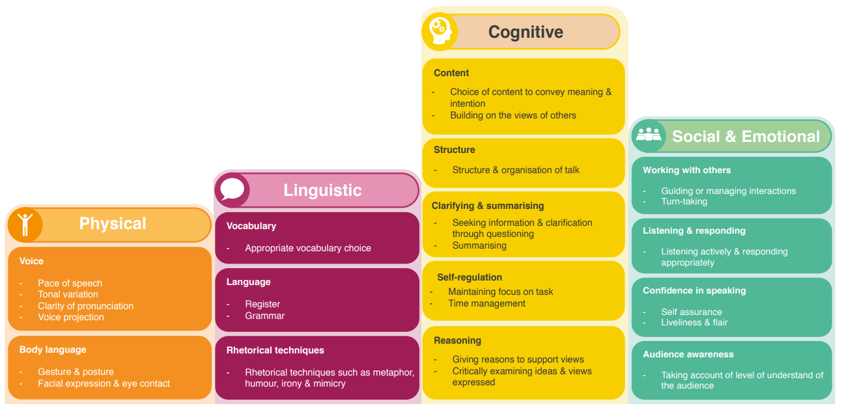
At Kettlefields, we have adopted an oracy framework which splits the speaking and listening elements into four strands. This will support children to understand the physical, linguistic, cognitive and social and emotional skills that enable successful discussion, inspiring speech and effective communication. Each class will have an area dedicated to oracy and display this framework in a child-friendly way.
Why is oracy important?
Oracy increases confidence, empowering children to believe that their voice has value as they develop the ability to articulate thoughts so that others will listen. It also improves academic outcomes, developing learners who can think critically and have the vocabulary to express knowledge and understanding. Furthermore, oracy fosters well-being supporting children to build successful relationships, express feelings and resolve conflicts. Finally, oracy equips students to thrive in later life helping them to access employment and engage in civil life.
Oracy at Kettlefields
Oracy will be delivered explicitly throughout the curriculum where they will be taught skills across the strands mentioned, using sentence stems to support them when necessary. Rich vocabulary will be explored and children will have the opportunity discuss, debate and recite themes on a range of topics. Our lessons are rich in talk, questions are carefully planned and conversations are scaffolded and modelled with the teachers using talk effectively to develop deeper thinking. Children are given opportunities to develop their oracy skills and build their confidence in talking in formal and informal situations, both inside and outside the classroom.

How you can help to promote oracy at home
- Read aloud to your child and discuss the story
- Record a video diary
- Play word games
- Talk about your child’s day, discuss the news (child appropriate of course),
- Phone a friend or relative
- Go for a walk and discuss the environment
- Ask probing questions that require some reasoning such as: What do you think about…? Can you explain how you did that? Do agree/disagree with …? Why?
- Play a game and ask your child to explain the rules
- Ask fun but probing questions: Would you rather … or …? Which famous person would you invite to your party? Why?
A fantastic website to explore with lovely ideas and resources (free): https://wordsforlife.org.uk

Our Vision for Oracy at Kettlefields
At Kettlefields, our vision is to have oracy at the heart of learning, to create language-rich classrooms and talk-rich children. Through the explicit teaching of oracy, we will develop children’s language skills to support everyone to find their voice, empowering them to speak effectively and express themselves confidently, whilst listening and responding attentively.
Oracy is recognised at Kettlefields as a skill for life and an essential tool for learning.

